
Session 4 Prepare: Architecture, UML and Workflow Modelling
About 20 minutes before the session. It sets up this afternoon's work; you do the tasks live.
Fictional organisation and synthetic data: the organisation, its people and its figures are invented for teaching.

Why this matters
This morning you described what the Tenant Repairs Portal must do. This afternoon you design how it is built: you draw its classes, show how one request moves through them, and use the Repair Requests data to find where reports wait longest. Developers use these diagrams to agree a design before writing code, and to explain it to the people who will build, test and pay for it.

1. Read the UML notation guide (10 minutes)
The guide uses a dental booking app, not Kestrel Moor Homes, so you learn the notation without seeing any answers.

Class diagram: the parts and how they relate
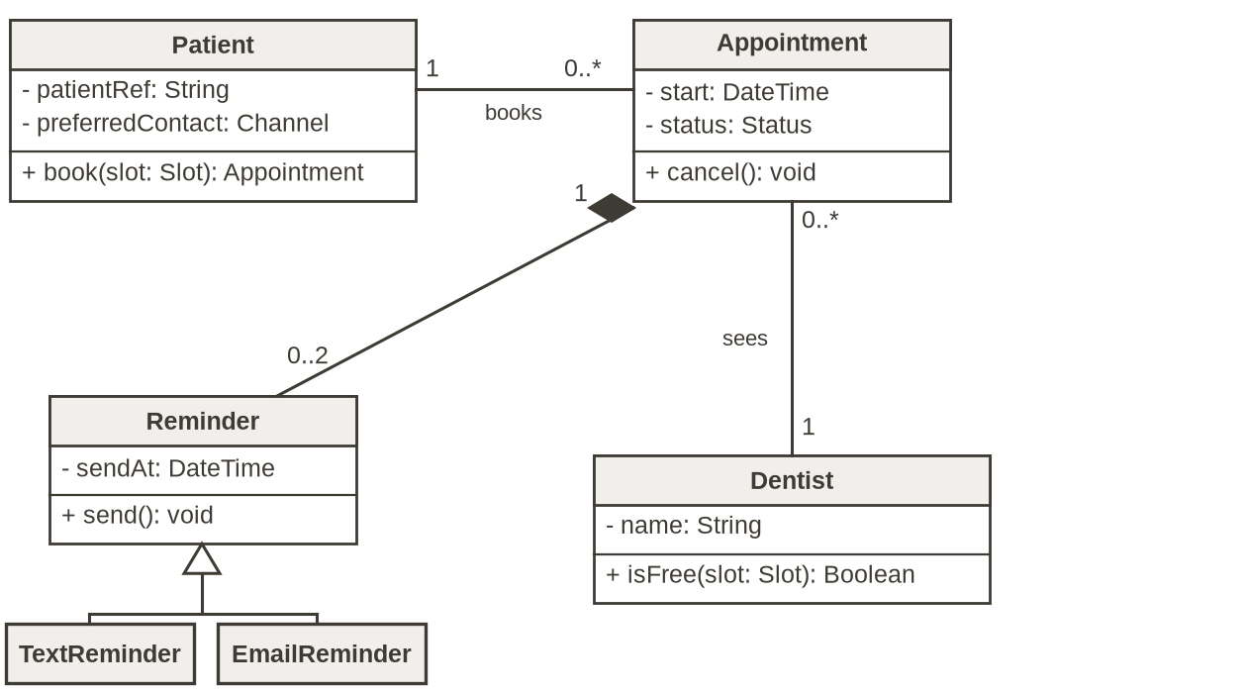
• A class box has three parts: the name (a singular noun), attributes (what each object knows, written name: Type) and operations (what it does, written name(parameters): ReturnType).
• Visibility: - private, + public. Keep data private and expose behaviour.
• Association (plain line): Patient books Appointment. Multiplicity is read across the line: one patient books 0..* (any number of) appointments; each appointment is booked by 1 patient.
• Composition (filled diamond at the whole): an appointment's reminders go with it. Generalisation (hollow triangle at the parent): TextReminder and EmailReminder are kinds of Reminder.

Sequence diagram: what happens, in order
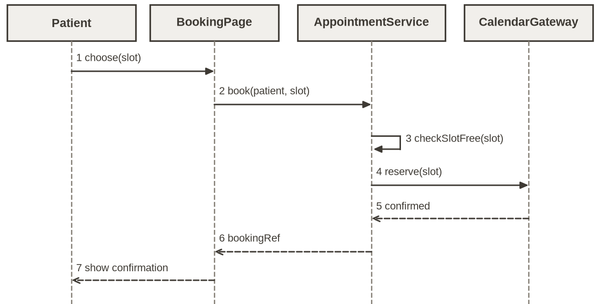
• Each participant has a box and a dashed lifeline; time runs down the page.
• Calls are solid lines with filled arrowheads, named like operations. Replies are dashed lines with open arrowheads, carrying the result back.
• A self-message (an arrow that loops back) shows an object doing a check itself, such as checkSlotFree(slot) on the server.
• Numbered messages let a reader follow the diagram and discuss it.

2. Check you can open the data (5 minutes)
1 Download your own copy of Kestrel Moor Homes - Repair Requests.xlsx from the Teams class channel Files tab and open it (Excel on your device, or Excel for the web from your own OneDrive). Work in your copy: the Files-tab copy is shared by the class. No spreadsheet application on your device: you will pair with a partner who shares their screen.
2 On the Requests sheet the filter arrows are already on in the header row. Filter property_type to Sheltered flat, check the row count changes, then clear the filter.
3 Open the Data dictionary sheet and find one column you do not understand. Write down its name and your question.

3. Think about the start question (5 minutes)
Reread Lee Carter's interview in the Case Brief, Part 5, and the description of today's job sheet in Part 1. Note two or three answers to the question below; you will share one in the chat.
The tutor will ask at the start: What would a contractor need from our design that a tenant would not?

